

ALLIED TELESIS BACKUP CONFIGURATION MANAGEMENT

Dikembangkan oleh : Yohanes Octavian Rizky – Operational Support
Platform : Windows 10/11 (64-bit)
Tanggal : Oktober 2025

DAFTAR ISI
- Pengenalan Aplikasi
- Spesifikasi & Instalasi
- Fitur-Fitur Utama
- Panduan Penggunaan
- Kebutuhan Backup
- Screenshot & Visual Guide

1. PENGENALAN APLIKASI
1.1 Tentang Aplikasi
Allied Telesis Backup Configuration Manager adalah aplikasi desktop untuk melakukan backup konfigurasi switch Allied Telesis secara otomatis dan manual. Aplikasi ini membantu administrator jaringan mengelola, menyimpan, dan membandingkan konfigurasi switch dengan mudah dan aman.
Keunggulan Utama
✅ User-Friendly : Interface intuitif dengan tema modern
✅ Secure : Enkripsi kredensial dengan master password
✅ Automated : Scheduling backup otomatis (harian/mingguan/bulanan)
✅ Real-Time : Auto-refresh data setiap view
✅ Multi-Protocol : Support SSH dan Telnet
✅ Comparison : Diff view untuk bandingkan konfigurasi

2. SPESIFIKASI & INSTALASI
2.1 Kebutuhan Sistem
Komponen | Spesifikasi
OS | Windows 10/11 64-bit
RAM | 2-4 GB
Disk | 500 MB
Network | Akses ke switch
2.2 Instalasi
- Extract file AlliedTelesisBackup_v1.0.0.zip
- Jalankan AlliedTelesisBackup.exe atau Start.bat
- Set master password pada first run
- Aplikasi siap digunakan
Struktur Folder:
text
AlliedTelesisBackup/
├── AlliedTelesisBackup.exe
├── Start.bat
├── data/ (Database)
├── backups/ (File backup)
└── logs/ (Log aplikasi)
- 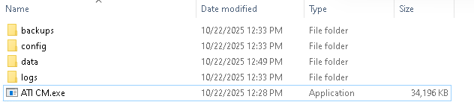

3. FITUR-FITUR UTAMA
3.1 Dashboard
Fungsi:
- Statistik real-time (Total Switches, Backups, Success Rate)
- Chart visualisasi backup status
- Recent activity log
- Auto-refresh setiap 30 detik
Komponen:
- Stat Cards : 4 kartu statistik utama
- Pie Charts : Backup status & Schedule status
- Activity Log : 10 aktivitas terakhir
- Refresh Button: Manual refresh

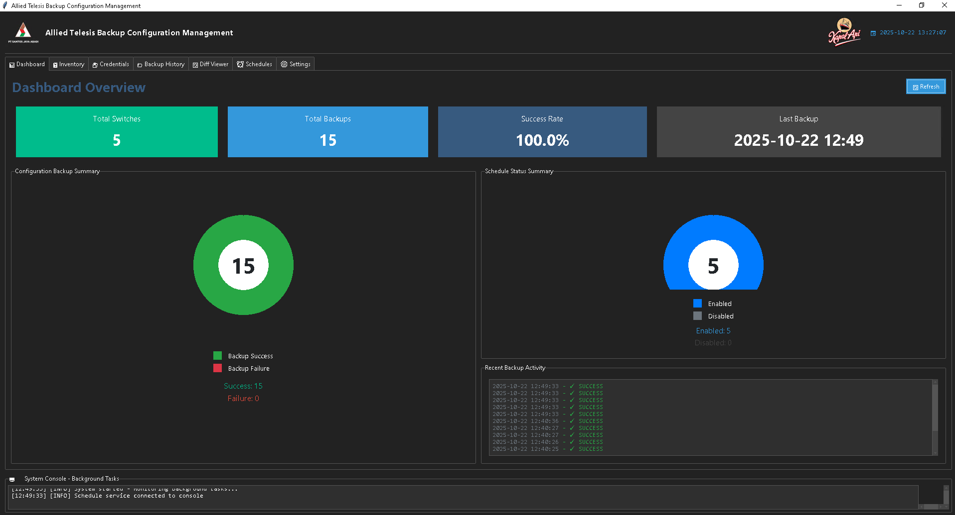

3.2 Inventory (Manajemen Switch)
Fungsi:
- Mengelola daftar switch
- Backup manual per switch
- Batch import dari CSV
- Monitoring status backup
- Auto-refresh setiap 30 detik

Fitur Utama:
A. Tabel Switch
Kolom: ID, Name, IP, Protocol, Port, Credential, Last Backup, Status
B. Tombol Aksi
- ➕ Add Switch
- ✏️ Edit
- 🗑️ Delete
- 📋 Batch Import
- 📥 Get Data (manual backup)
- 🔄 Refresh
C. Dual Console
- Kanan: Output backup manual
- Kiri: Background tasks & system messages

Inventory View
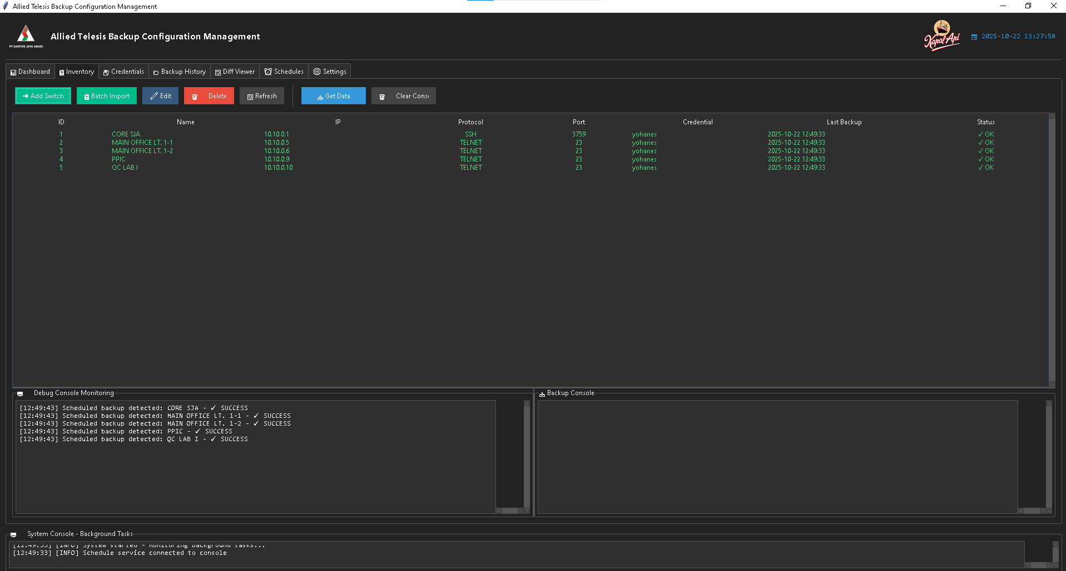
Add Switch Dialog
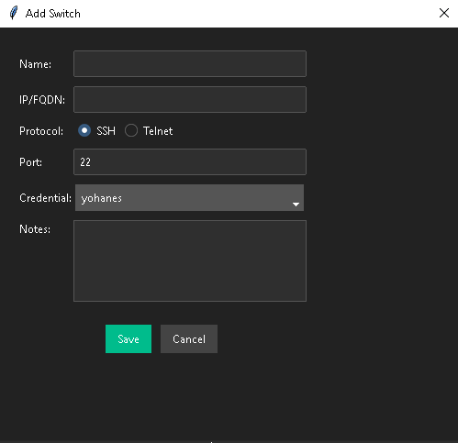
Manual Backup Console
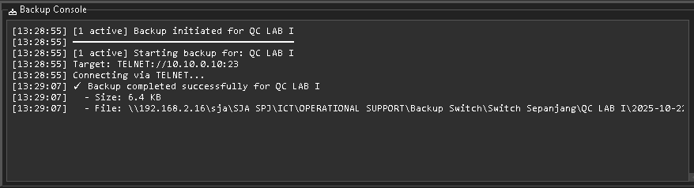

3.3 History (Riwayat Backup)
Fungsi:
- Menampilkan history semua backup
- Filter: Switch, Type (Manual/Auto), Month, Search
- View, Export, dan Open folder backup
- Auto-refresh setiap 30 detik

Color Coding:
- Hijau : Auto backup sukses
- Cyan : Manual backup sukses
- Merah : Auto backup gagal
- Orange: Manual backup gagal

Backup Content Viewer
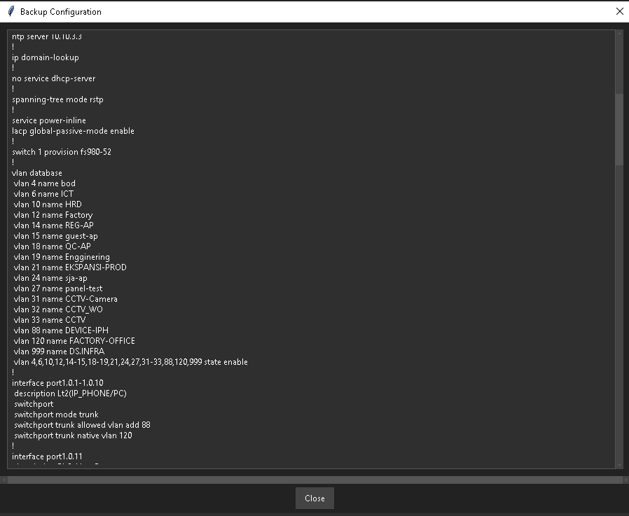

3.4 Diff View (Perbandingan Konfigurasi)
Fungsi:
- Membandingkan 2 konfigurasi switch
- Filter month individual untuk Before & After
- Manual file browse (compare file dari komputer)
- Side-by-side comparison dengan color coding
- Export hasil diff

Diff View Selection
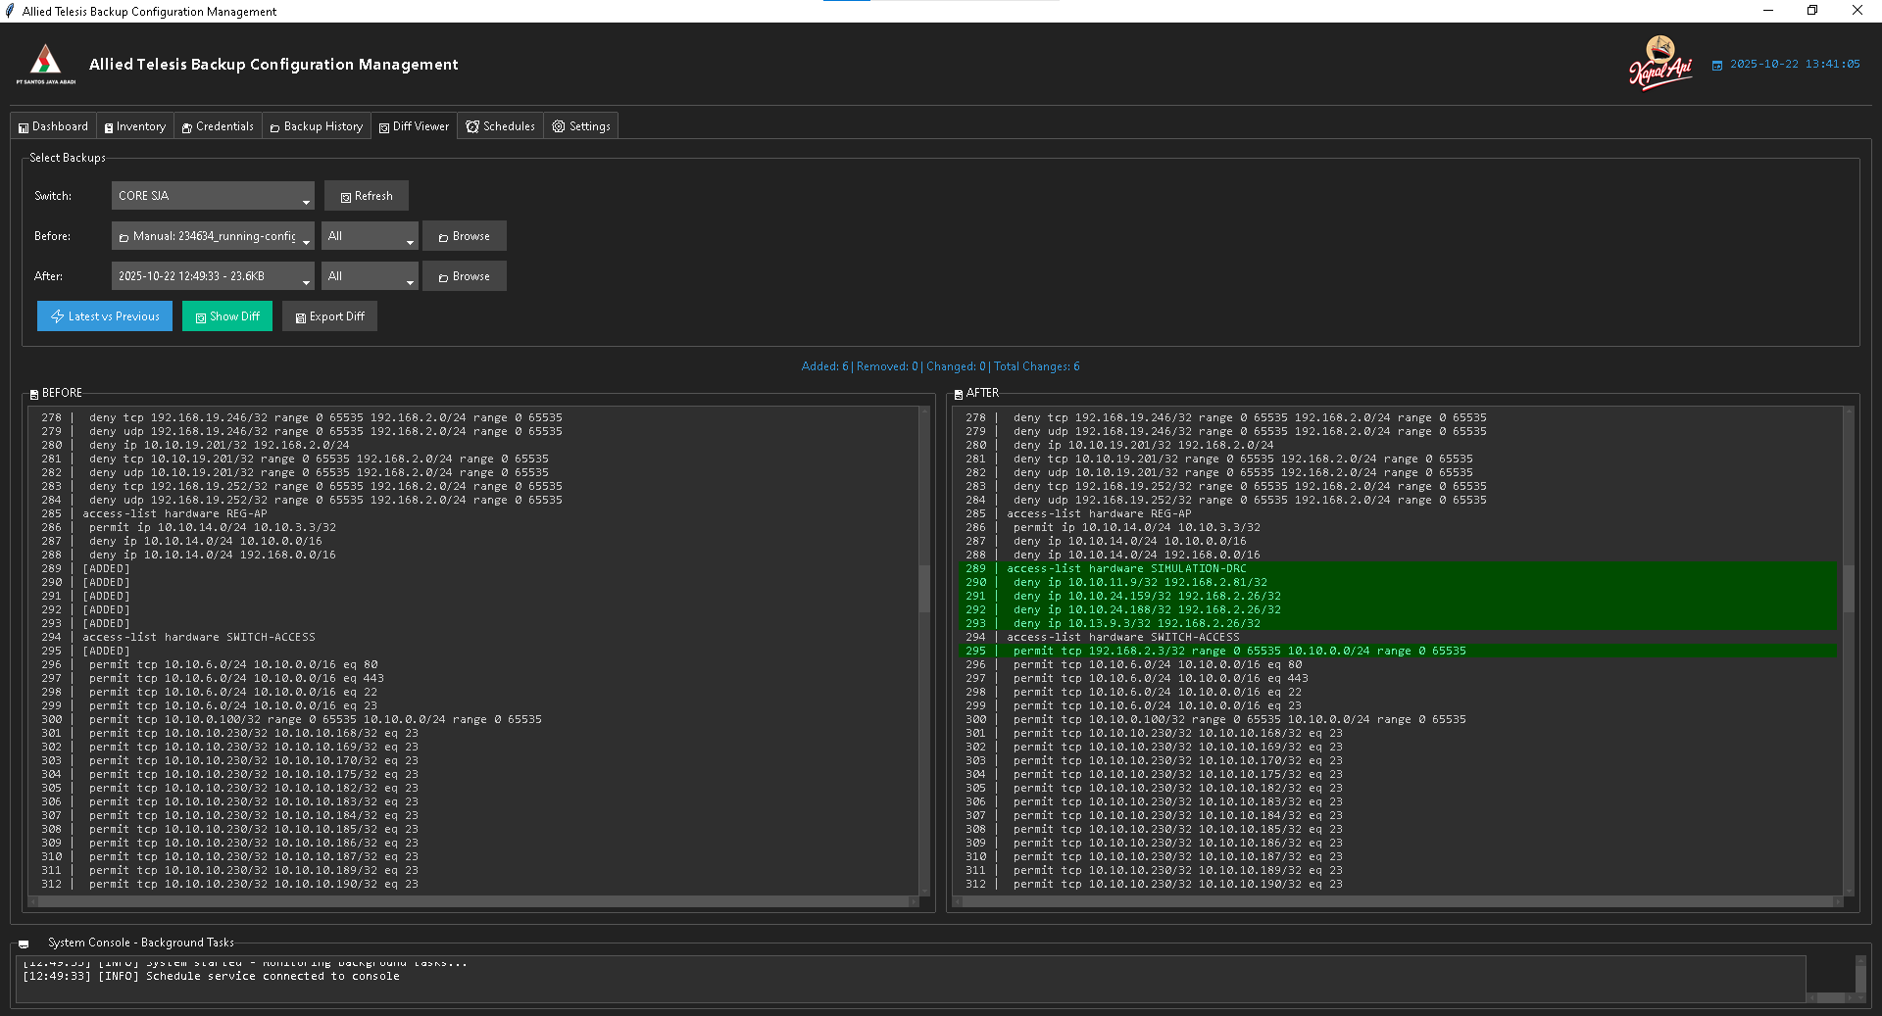

3.5 Schedules (Penjadwalan)
Fungsi:
- Membuat jadwal backup otomatis
- Interval: Minutes, Hours, Daily, Weekly, Monthly
- Enable/Disable schedule
- Start Now (manual trigger)
- Auto-refresh setiap 10 detik
Interval Types:
- Minutely: Every X minutes (1-59)
- Hourly: Every X hours (1-23)
- Daily: Every day at HH:MM
- Weekly: Every 7 days at HH:MM
- Monthly: Every 30 days at HH:MM

Schedules View
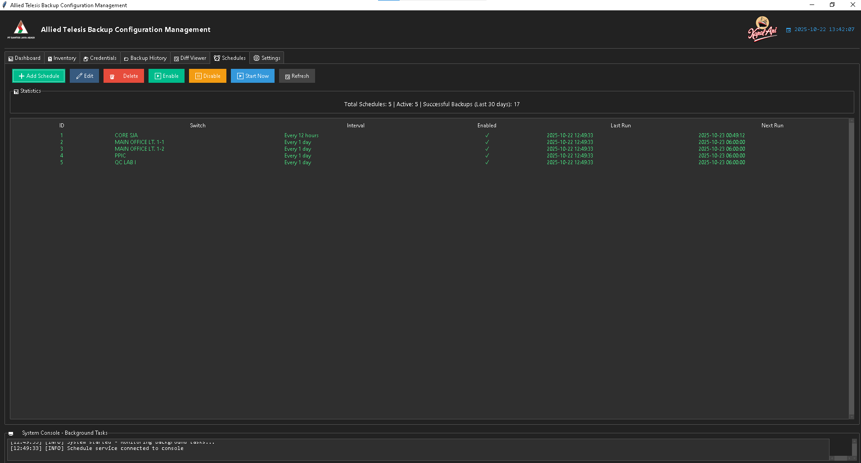
Add Schedule Dialog
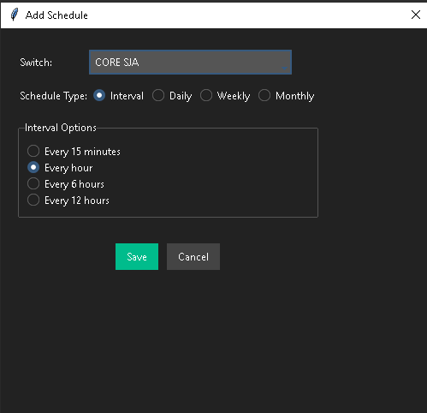

3.6 Credentials (Manajemen Kredensial)
Fungsi:
- Mengelola username/password switch
- Enkripsi dengan Fernet (symmetric encryption)
- Add, Edit, Delete credentials
- Enable password optional (privilege escalation)
- Auto-refresh setiap 60 detik
Tabel Credentials:
Kolom: ID, Name, Username, Has Enable Password, Created, Updated
Security:
- Password dienkripsi
- Master password protection
- No plain text storage

Credentials View
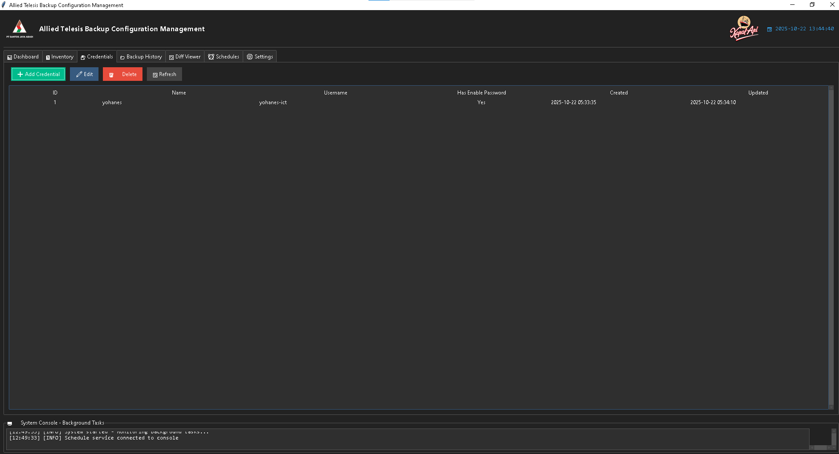

Add Credential Dialog
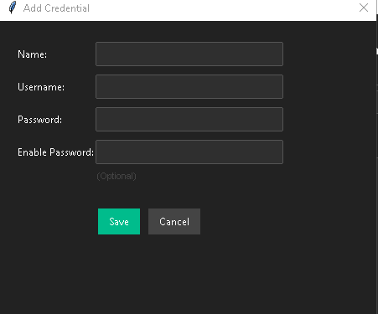

3.7 Settings (Pengaturan)
A. Backup Settings
- Retention days (default: 365 )
- Backup path
- Compression
B. Network Settings
- Connection timeout
- Retry attempts
- Command timeout
C. Security
- Change master password
E. Logging
- Log level
- Log retention

Settings View
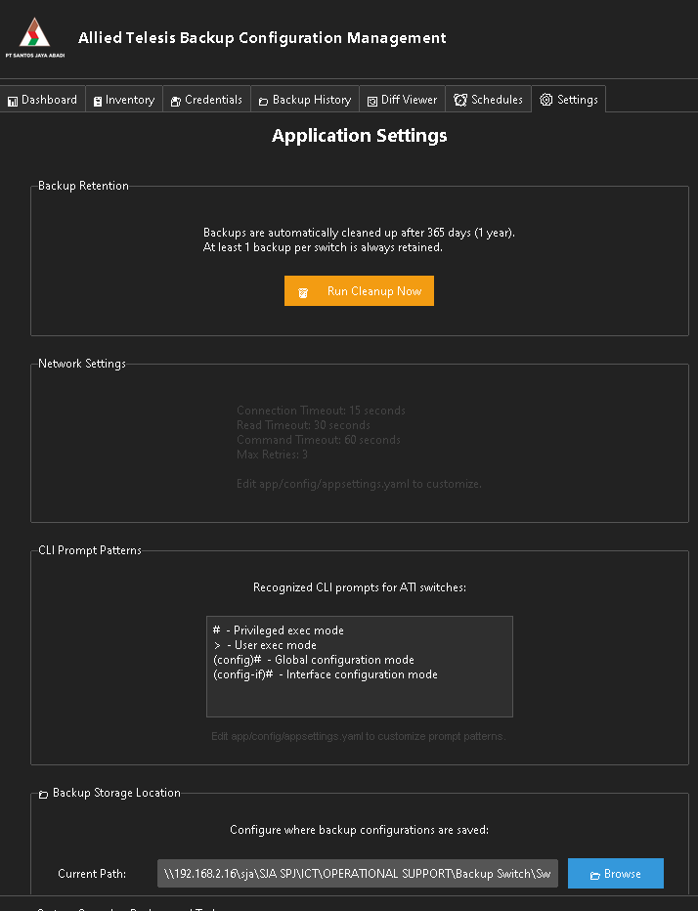
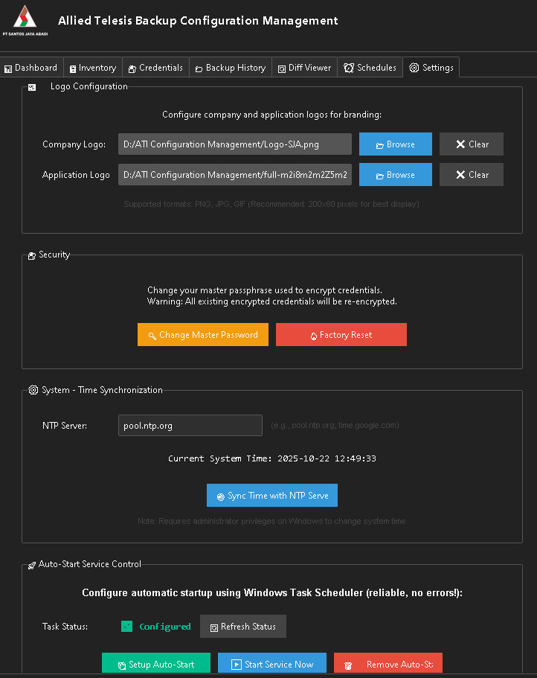
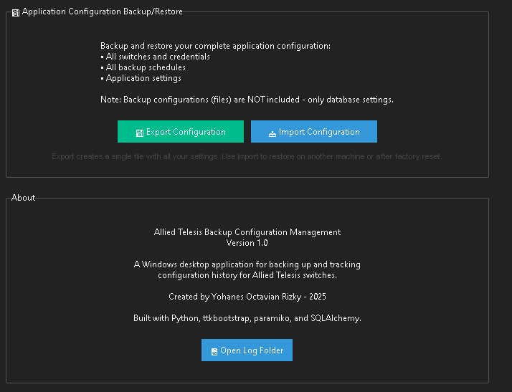

4. PANDUAN PENGGUNAAN
4.1 Quick Start (5 Menit)
LANGKAH 1: Setup Awal
- Jalankan aplikasi
- Set master password (simpan baik-baik!)
- Konfirmasi password
LANGKAH 2: Tambah Credential
- Buka tab Credentials
- Klik ➕ Add Credential

- Isi:
  - Name: admin_ssh
  - Username: manager
  - Password: [password switch Anda]
- Save
LANGKAH 3: Tambah Switch
- Buka tab Inventory
- Klik ➕ Add Switch
- Isi:
  - Name: Switch-Core-01
  - IP: 192.168.1.1
  - Protocol: SSH
  - Port: 22
  - Credential: admin_ssh
- Save
LANGKAH 4: Test Backup
- Pilih switch dari tabel
- Klik 📥 Get Data
- Monitor console untuk progress
- Cek tab History untuk hasil
LANGKAH 5: Setup Schedule
- Buka tab Schedules
- Klik ➕ Add Schedule
- Pilih switch: Switch-Core-01
- Interval: Every 1 day at 02:00
- Centang Enabled
- Save
4.2 Workflow Backup Manual
text
1. Inventory → Pilih Switch → Get Data
2. Monitor Console untuk progress
3. Cek status di kolom "Last Backup"
4. Lihat hasil di tab History
5. (Optional) View atau Export backup
4.3 Workflow Backup Otomatis
text
1. Credentials → Add credential
2. Inventory → Add switch
3. Schedules → Add schedule → Enable
4. System akan backup otomatis sesuai schedule
5. Monitor di Dashboard (Recent Activity)
6. Check hasil di History
4.4 Workflow Compare Konfigurasi
Scenario 1: Compare Database Backups
text
1. Diff View → Pilih Switch
2. Before: Pilih backup lama
3. After: Pilih backup baru
4. Show Diff
5. Analisa perbedaan (red/green/yellow)
6. (Optional) Export Diff
Scenario 2: Compare dengan File Manual
text
1. Diff View → Pilih Switch
2. Before: Pilih dari database
3. After: Click 📁 Browse → Pilih file
4. Show Diff
5. Analisa perbedaan
5. KEBUTUHAN BACKUP
5.1 Mengapa Perlu Backup Konfigurasi?
Alasan Utama:
1. Disaster Recovery
- Switch failure → Restore konfigurasi cepat
- Hardware replacement → Apply config ke switch baru
- Minimize downtime
2. Audit & Compliance
- Track perubahan konfigurasi
- Compliance reporting
3. Change Management
- Bandingkan before/after perubahan
- Rollback jika ada masalah
- Documentation perubahan
4. Security
- Detect unauthorized changes
- Backup sebelum maintenance
- Investigation security incidents
5. Best Practice
- Industry standard
- Prevent data loss
- Peace of mind

5.2 Strategi Backup
Rekomendasi Interval:
Production Switches (Critical):
- Daily: Backup setiap 12 jam
- Before Change: Manual backup sebelum perubahan
- After Change: Manual backup setelah perubahan
- Retention: 90 hari
Distribution Switches:
- Weekly: Backup setiap hari
- Before Change: Manual backup sebelum perubahan
- Retention: 60 hari
Access Switches:
- Monthly: Backup setiap hari
- Ad-hoc: Manual backup saat perubahan
- Retention: 30 hari

LAMPIRAN
Format CSV untuk Batch Import
csv
name,ip,protocol,port,credential_name,notes
Switch-Core-01,192.168.1.1,ssh,22,admin_ssh,Main Core Switch
Switch-Dist-01,192.168.1.10,ssh,22,admin_ssh,Distribution Floor 1
Switch-Access-01,192.168.1.100,telnet,23,user_telnet,Access Switch Lab

Command Reference
Command | Function
Ctrl + R | Refresh current view
Ctrl + F | Search/Filter
Ctrl + S | Save
Escape | Close dialog
F1 | Help
F5 | Manual refresh
File Locations
Item | Location
Database | data/backups.db
Backups | backups/[switch_name]/
Logs | logs/app_[date].log
Config | app/config/appsettings.yaml
Dokumentasi ini dibuat untuk aplikasi Allied Telesis Backup Configuration Manager v1.0.0
Terakhir diupdate: Oktober 2025
*© 2025 - All Rights Reserved*

